Choreo Graph Activity 4: Angle Dance Moves with a Mood
Exploring Angle Types
Overview
Students will make use of different angle types, as they create dances, (e.g. linear pairs, complementary, supplementary, or right angles) to achieve a desired mood.
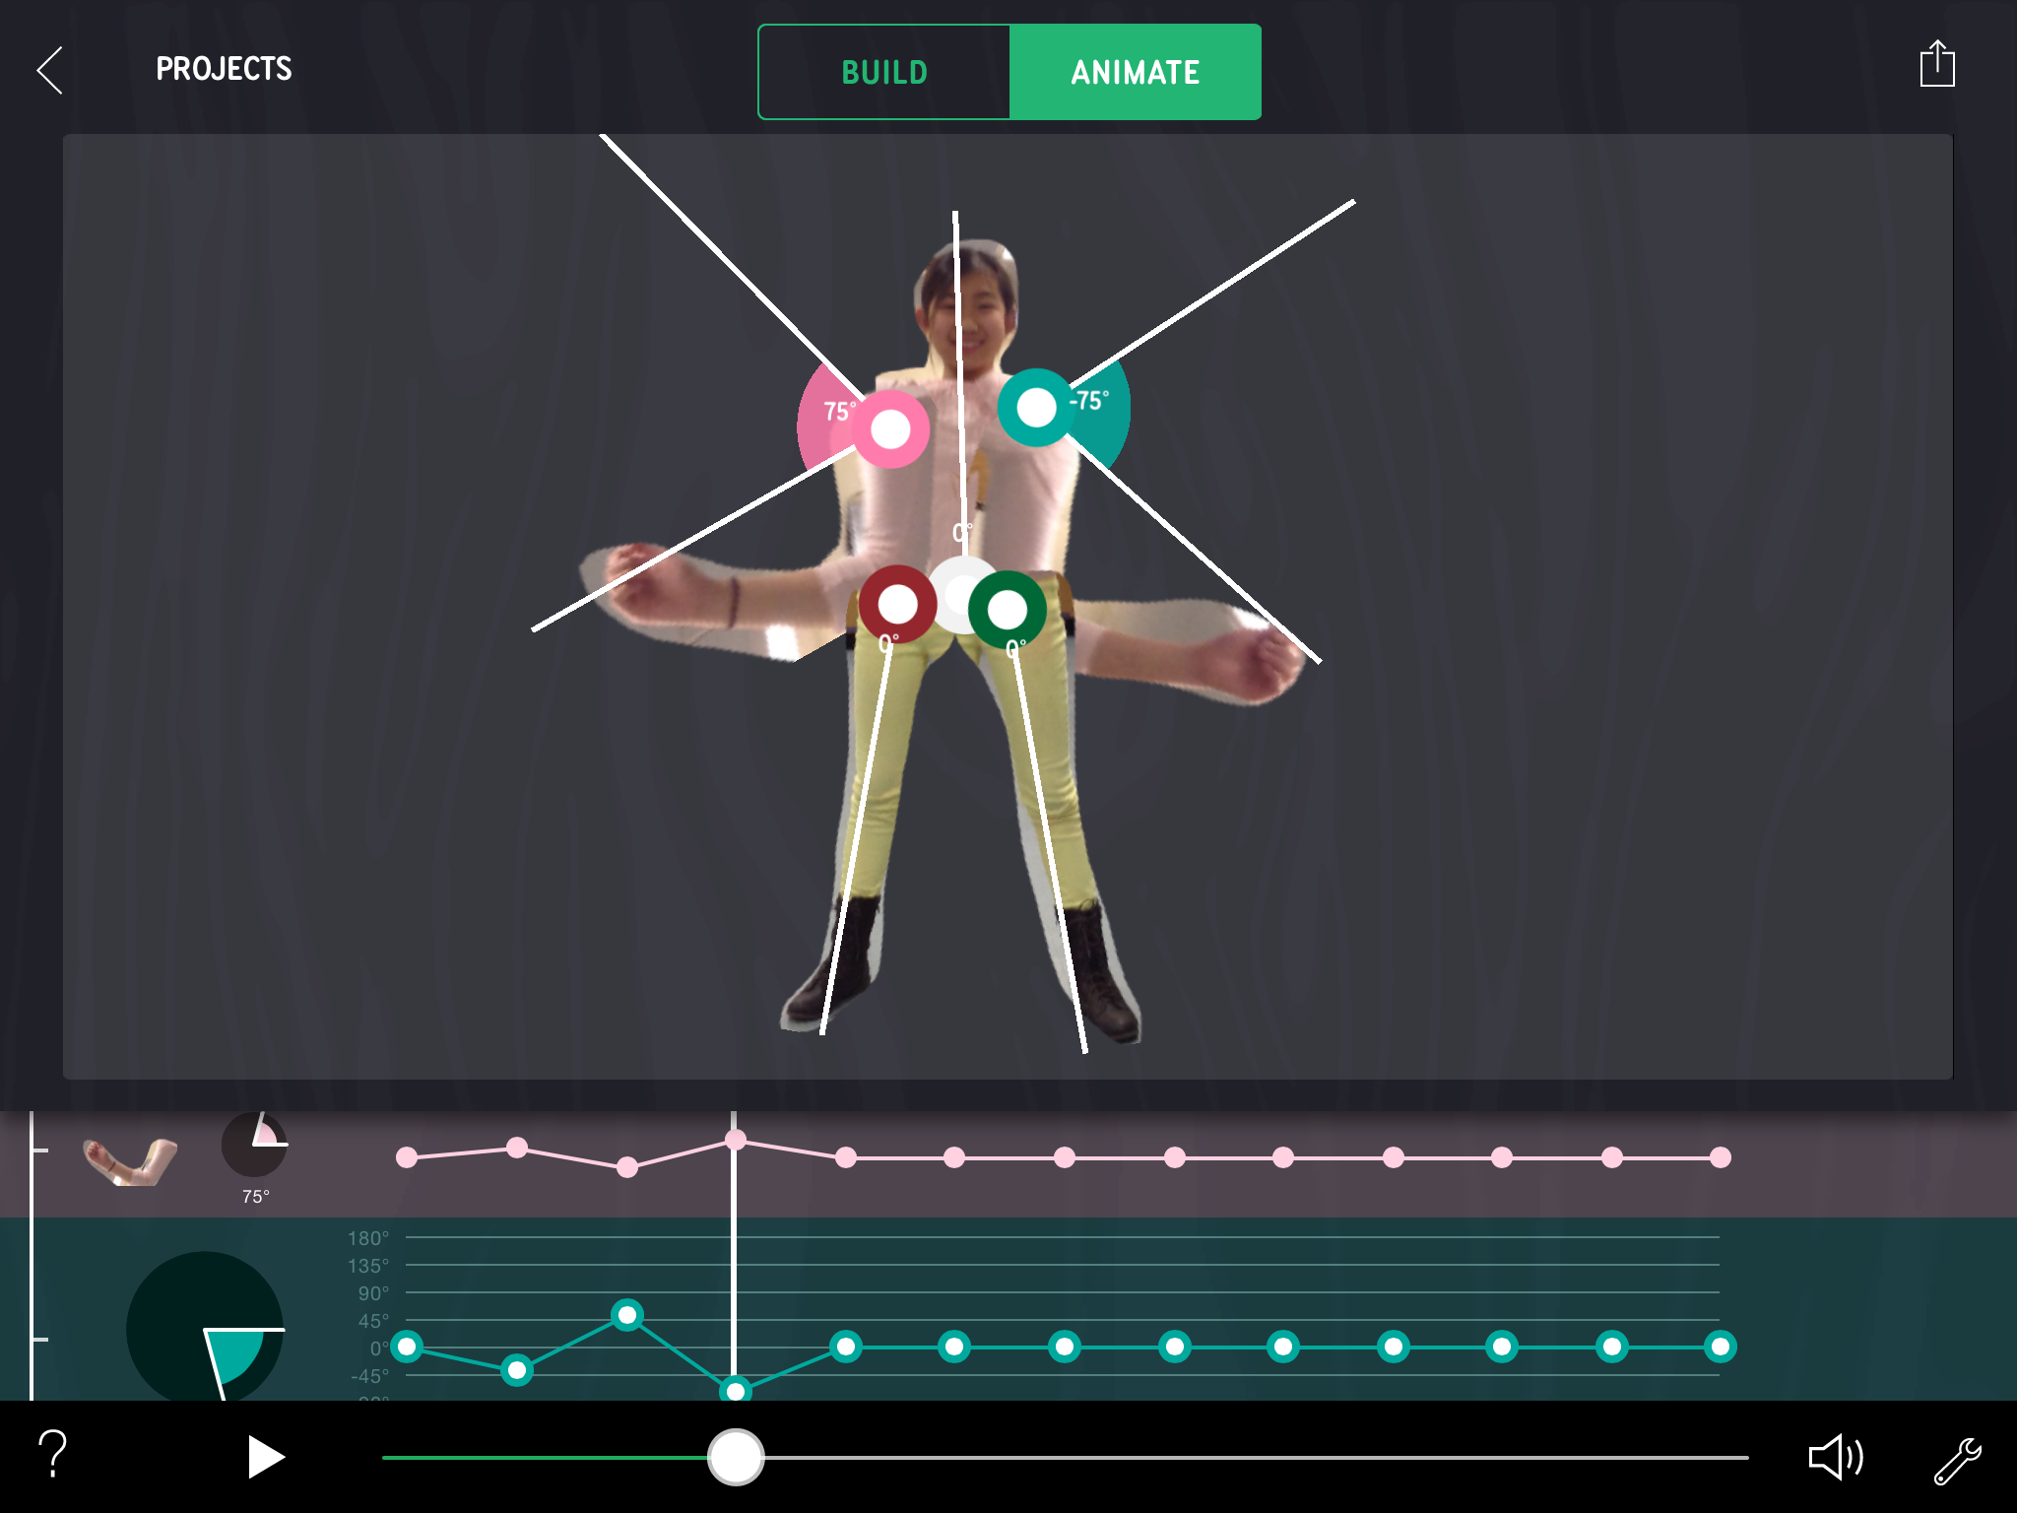

Big Idea
In this activity, students will learn about different angle types as they create a dance using different angles of rotation to create a mood.

Learning Objectives
- Students will explore angle measurement and the relationships between different angle types
- Students will engage in computational thinking as they work with graph controllers and key frames to create, develop, and perfect their animated dances.

Vocabulary
- Right angles (90 degrees)
- Acute
- Obtuse
- Complementary Angles (two angles adding up to 90 degrees)
- Supplementary Angles (two angles adding up to 180 degrees, also known as a linear pair)
- Vertical angles (angles opposite each other when two lines cross, always equal)

Grades
Middle School, 6-8

Standards Addressed
Common Core State Standards-Math
Geometry
7.G.B 5. Use facts about supplementary, complementary, vertical, and adjacent angles in a multi-step problem to write and solve simple equations for an unknown angle in a figure.

8.G.A.5. Use informal arguments to establish facts about the angle sum and exterior angle of triangles, about the angles created when parallel lines are cut by a transversal, and the angle-angle criterion for similarity of triangles.
Common Core State Standards-Math
Mathematical practices.
MP2: Reason abstractly and quantitatively.
Students create a dance visually and then have to determine the quantitative moves before making it virtual.

MP4: Model with mathematics.
Students outline their dance using the angles of rotation and the coordinate notation for the translation.

Classroom Strategies
Single-device implementation
Ask a volunteer to be photographed or use the prefabricated robot parts available in the app to create a dancer. Using an interactive white board or projector, invite students to direct each move, using mathematical language.

Multiple-device implementation
This activity works when classrooms have 1:1 devices but it is also great for groups of 2 or more per iPad Assign students different roles. Have the group consider what moves they would like to create by acting it out first, sketching it, then animating their friend or object to make a move.

Tips and Tricks
Acting Out the Angle Types: To get started, have students act out or visualize through sketching the different angles of rotation for their dance moves. Have them consider unrealistic moves. For inspiration, show this vintage link: Square One TV Angle Dance

Angle Measurements: The starting position of each of the dancer’s parts will have the angle measurement set to zero. You can change the angle measurements for each key frame by stretching points on the graph or by moving it in the desired direction on the animation stage. To clear out an angle measurement to zero again, just hold down your finger on the graph controller’s pie graphic, and tap clear.

App Features
Begin by entering Make Some Moves. In Build mode, students will:
- Take Pictures
- Trace and cut out parts of your photo that you want to animate
- Add graphic or musical elements below:

In Animate mode, students will use the:

Graph Controllers. Choreo Graph uses keyframes much like other movie editing software. At each point in the keyframe, the student can manipulate how each part of the animation rotates. Each node on the line graphs below the stage represents the position of that part at a specific time. Stretch the points up and down to set the degrees of rotation. The steeper the line on the graph, the faster the part moves.

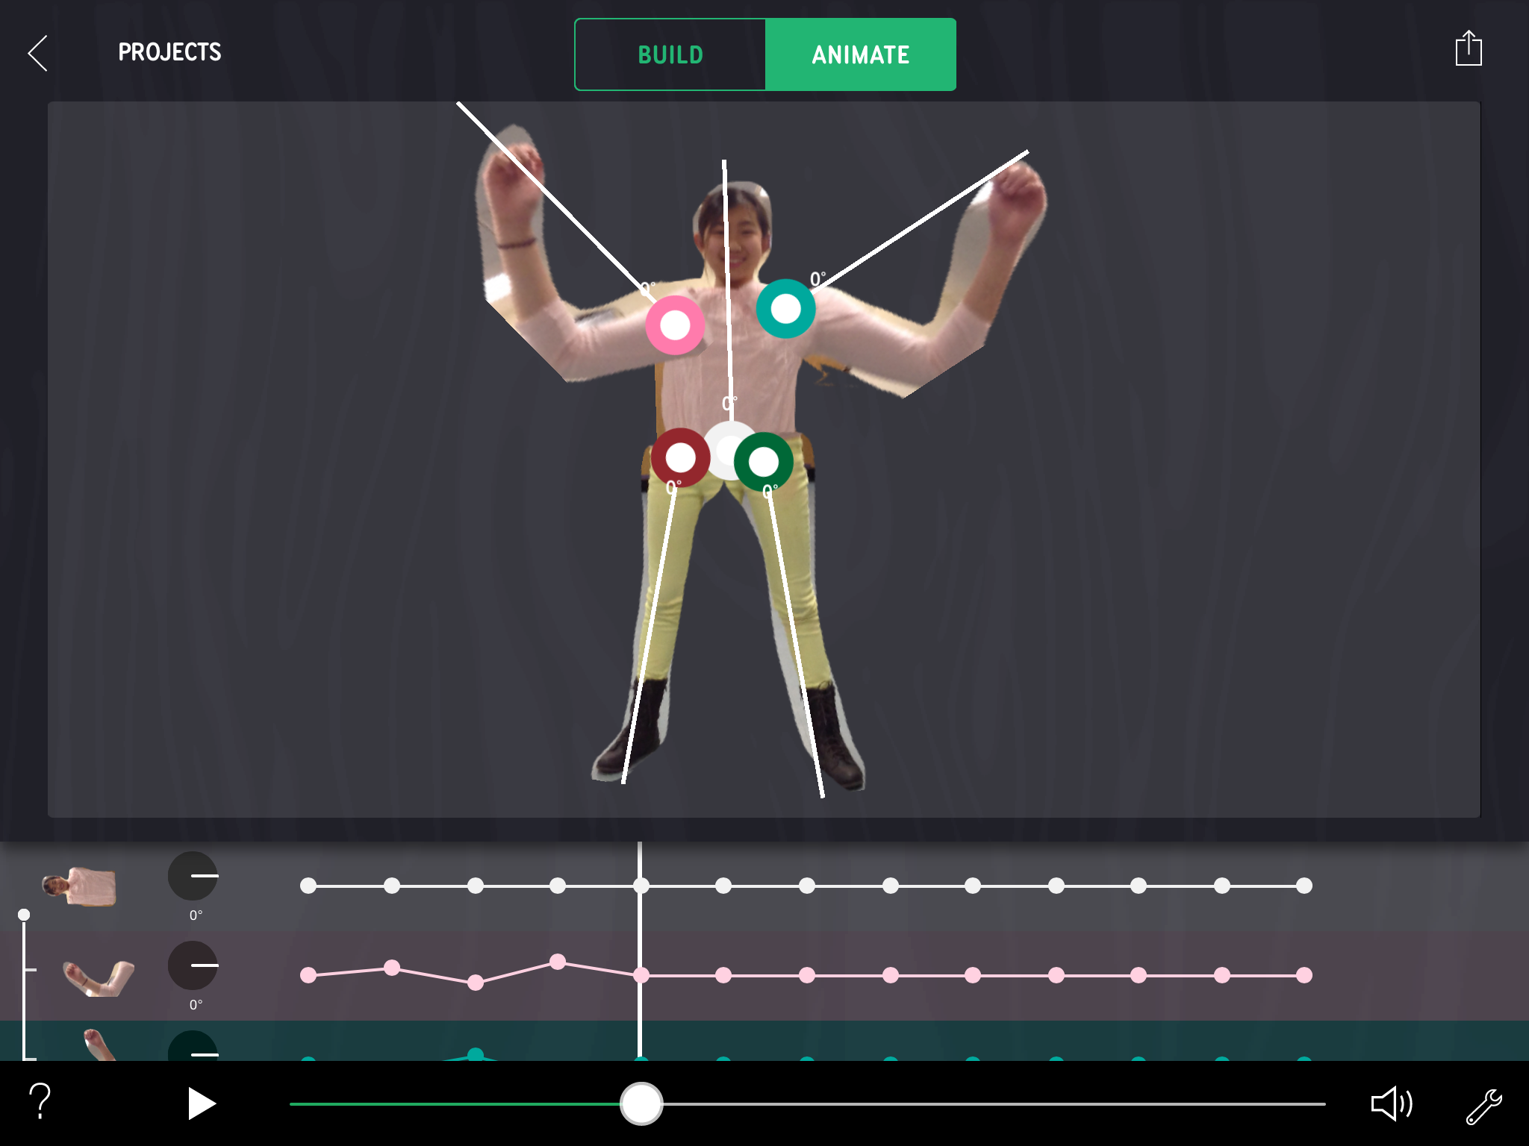

Toggle on math tools to notice:

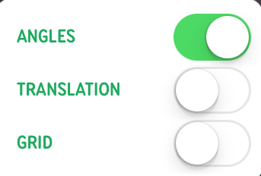
-Degrees each part has rotated

Expected Activity Time
Part 1: Angle Type Exploration (20-40 minutes)
Part 2: Dance with Angle Combos to Create a Mood (20 minutes)

Materials and Prep
- Angle Dance Moves with a Mood Student Sheets
- iPad with Choreo Graph app
- Wifi access for sharing to hub

Introducing the Activity
Create simple dances in which the dancer’s parts rotate at: 1) 90 degrees; 2) acute angle measurements; 3) obtuse angle measurements. Then create dances with angle pairs (i.e., complementary and supplementary angles). Use what you learn to create a final dance with different angle types. What mood or effect do you achieve from each dance?

To Do
Part 1: Angle Type Exploration (20-40 minutes)
Have students try three types of angle dance moves:
- Right Angles: Create a simple dance in which all the parts only rotate at +90 or -90 degree angles. Save the dance to share with the class later. What are some things you notice about your dancer as its parts only rotate 90 degrees? Did anything surprise you?

- Acute and Obtuse Angles: Make a simple dancer whose parts only rotate with acute angle measurements. Then create a simple dance where all the parts rotate with obtuse angle measurements. Save each of these as projects. When you animate the two dances, what are some things you notice?

- Angle Pairs: Explore angle pairs (i.e., complementary and supplementary angles). Create a simple dance where pairs of parts have these relationships. For example, one part will move 50 degrees and the part right next to it will move 130 degrees. Ask: When you animate these parts, what kind of effect do you get? Pleasing? Unrealistic?

- Vertical Angles: Repeat using two different parts to create a simple dance with vertical angles that rotate with equal measure but opposite each other.

Part 2: Dance with Angle Combos to Create a Mood (20 minutes). Based on explorations from the part 1, have students:
- Create a new dance by selecting different angle types to achieve a certain mood or effect.
- Describe what types of angles achieve certain effects, such as graceful, subtle, jerky movements, etc.
- Be sure students use mathematical language to describe the angular moves of their dance and the mood they create.

Discussion
While students are creating their final dance moves, it’s important to prompt their thinking around the following areas:
- Which types of angles did you enjoy using the most?
- What did you notice when you animated dances using the different angles?
- Which angle-based dance moves looked the most realistic?
- Which angle-based dance moves created the mood you were after? Why?

Listen for:
- Acute angles seem more subtle because they are moving less degrees.
- Because obtuse angles have greater degrees, they create more obvious movements.
- Vertical angles look opposite and equal.

Extensions and Inquiring Further
To help solidify what differentiates the angle types, have students identify the angle types incorporated into their classmates’ dances by viewing their animations without angle measurements turned on. Are they able to guess what angle types the dance contained? How accurate are they?

Name: __________________________ Date: _____________

Part 1: Angle Type Exploration

Acute Angles | Obtuse Angles | Right Angles
Angles that are less than 90 degrees | Angles that are more than 90 degrees | Angles that are equal to 90 degrees
Complementary Angles | Supplementary Angles | Vertical Angles
Two angles that add up to 90 degrees | Two angles that add up to 180 degrees (linear pair) | Vertical angles created by intersecting lines are equal

Explore Angle Types:
- Right Angles: Create a simple dance in which all the parts only rotate at +90 or -90 degree angles. Save your dance as a project to share with your classmates and teacher later. What are some things you notice about your dancer as its parts can only rotate 90 degrees? Did anything surprise you?
- Acute Angles: Now make a simple dancer whose parts only rotate with acute angle measurements. Also create a simple dance where all the parts rotate with obtuse angle measurements. When you animate the two dances, what are some things you notice?
- Angle Pairs: Let’s explore the angle pairs or complementary and supplementary angles. Create a simple dance where pairs of parts have these relationships. For example, one part will move 50 degrees and another part next to it will move 130 degrees. When you animate these parts, does anything stand out for you? How do these paired angles affect the dance?
- Vertical Angles: Finally, create a simple dance with vertical angles that rotate with equal measure but opposite each other. When you animate these parts, what stands out the most?

Name: __________________________ Date: _____________

Part 1: Angle Type Exploration
Dance Moves With Right Angles

- What are some things you notice about your dancer when its parts can only rotate 90 degrees?

- Did anything surprise you?

- Sketch your dance below. Be sure to include the angle measurements.

Name: __________________________ Date: _____________

Part 1: Angle Type Exploration
Dance Moves With Acute and Obtuse Angles

Make a simple dancer whose parts only rotate with acute angle measurements. Also create a simple dancer where all the parts rotate with obtuse angle measurements.

- When you animate the two dances, what are some things you notice?

- Sketch your dance below. Be sure to include the angle measurements.

Name: __________________________ Date: _____________

Part 1: Angle Type Exploration
Dance Moves With Angle Pairs

Let’s explore the angle pairs of complementary and supplementary angles. Create a simple dance where pairs of parts have these relationships. For example, one part will move 50 degrees and the part right next to it will move 130 degrees.

- When you animate these parts, does anything stand out for you? How do these paired angles affect the dance?

- Sketch your dance below. Be sure to include the angle measurements.

Name: __________________________ Date: _____________

Part 1: Angle Type Exploration

Dance Moves With Vertical Angles

Using two different parts on your dancer, create a simple dance with vertical angles that rotate with equal measure but opposite each other.

- When you animate these parts, what stands out most?

- Sketch your dance below. Be sure to include the angle measurements.

Name: __________________________ Date: _____________

Part 2: Dance With Angle Combos to Create a Mood

Based on your experience playing with these angles, create a dance that uses a combination of angles types.

1. Sketch your dance below. Be sure to include the angle measurements.

2. Describe the angle types that you used and why. Were you able to achieve the mood you set out to create?
Name: __________________________ Date: _____________

Part 1: Angle Type Exploration &
Part 2: Dance with Angle Combos to Create a Mood
Reflection Questions:

- Which types of angles did you enjoy using the most? Why?

- What did you notice when you animated the different dances using the different angles?

- Which angle-based dance moves looked the most realistic?

